# Task 2

1. Insert at least 10 sample records into each of the following tables.

• Customers

• Accounts

• Transactions

Output:

# Accounts table:

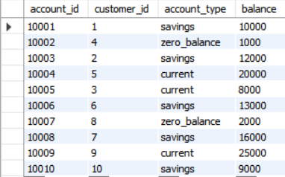

# Customers table:

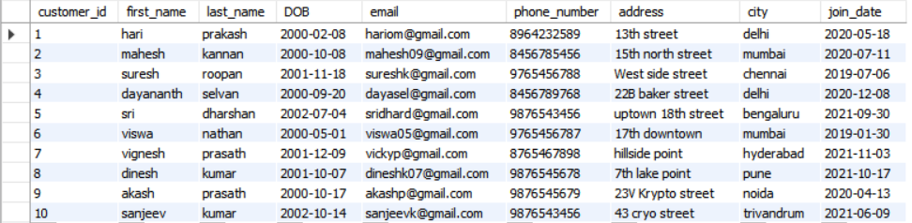

# Transaction table:

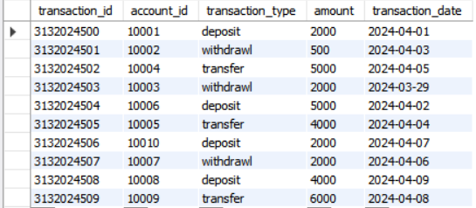

1. SQL queries:

1. Write a SQL query to retrieve the name, account type and email of all customers.

Query:

SELECT CONCAT(first_name,last_name) AS Name,

A.account_type AS Accounttype, email AS Email

FROM customers C

INNER JOIN accounts A ON C.customer_id=A.customer_id;

Output:

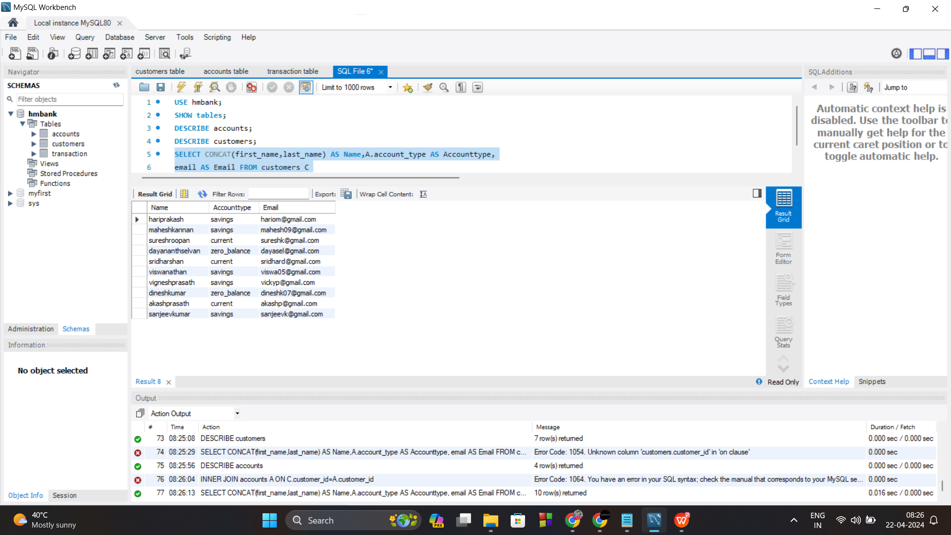

2. Write a SQL query to list all transaction corresponding customer.

Query:

SELECT C.customer_id,CONCAT(C.first_name,C.last_name)

AS name,T.transaction_id,T.account_id,T.transaction_type,

T.amount,T.transaction_date

FROM transaction T

JOIN accounts A ON T.account_id=A.account_id

JOIN customers C ON A.customer_id=C.customer_id

ORDER BY C.customer_id;

Output:

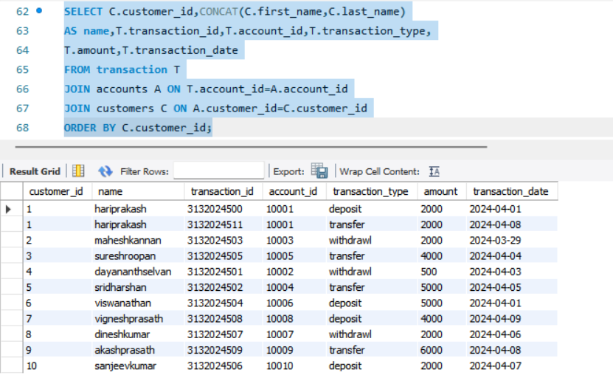

3. Write a SQL query to increase the balance of a specific account by a certain amount.

Query:

UPDATE hmbank.transaction

SET balance=balance + 3000

WHERE account_id=10005;

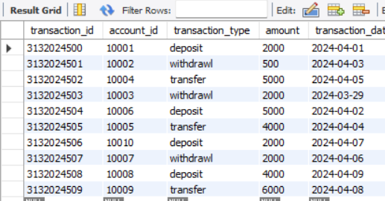

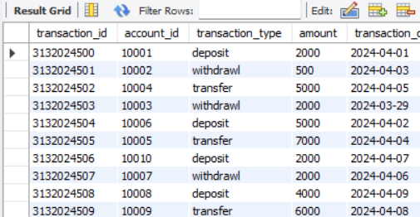



4.Write a SQL query to Combine first and last names of customers as a full_name.

Query:

SELECT CONCAT(first_name,last_name) AS full_name

FROM customers;

Output:

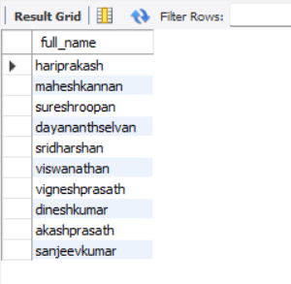

1. Write a SQL query to remove accounts with a balance of zero where the account

type is savings.

Query:

DELETE FROM accounts

WHERE balance = 0

AND account_type = 'savings';

Output:

Accounts table:

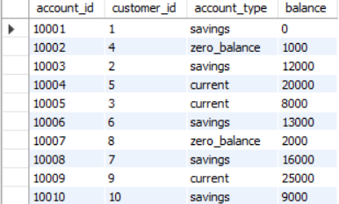

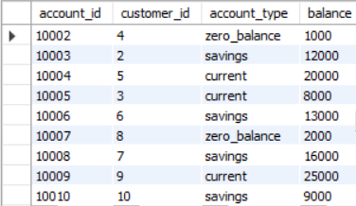

1. Write a SQL query to Find customers living in a specific city.

Query:

SELECT * FROM customers

WHERE city= ‘delhi’;

Output:

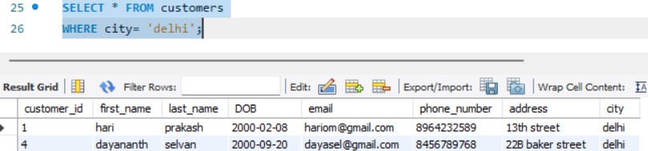

1. Write a SQL query to Get the account balance for a specific account.

Query:

SELECT account_id,account_type,balance

FROM accounts

WHERE account_id=10005;

Output:

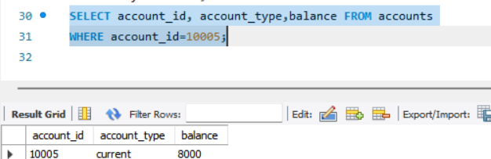

1. Write a SQL query to List all current accounts with a balance greater than 1,000 rupees.

Query:

SELECT account_id, account_type, balance

FROM accounts

WHERE account_type= ‘current’

AND balance>1000;

Output:

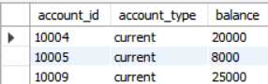

9. Write a SQL query to Retrieve all transactions for a specific account.

Query:

SELECT transaction_id, transaction_type,amount,transaction_date

FROM transaction

WHERE account_id=10001;

Output:

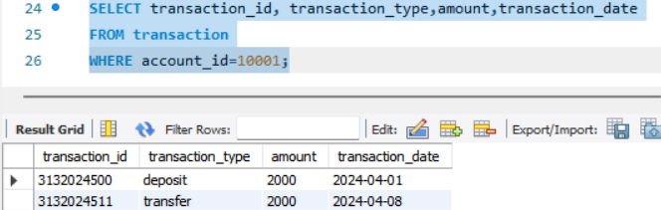

10. Write a SQL query to Calculate the interest accrued on savings accounts based on a

given interest rate.

Query:

SELECT account_id, account_type, balance, balance*0.2 AS interest FROM accounts;

Output:

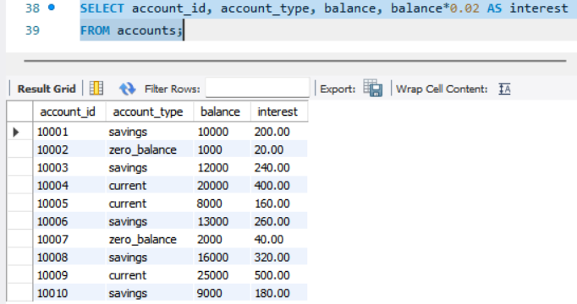

11. Write a SQL query to Identify accounts where the balance is less than a specified overdraft limit.

Query:

SELECT account_id,account_type, balance FROM accounts

WHERE balance<3000;

Output:

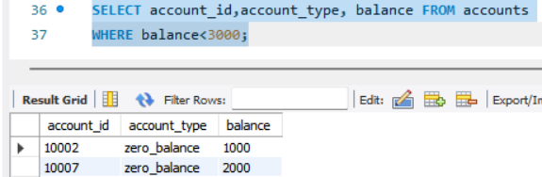

1. Write a SQL query to Find customers not living in a specific city.

Query:

SELECT * FROM customers

WHERE NOT city = ‘delhi’;

Output:

